Department of Computer Sc. & Engg.
FET (ITER), SOA Deemed to be University, Bhubaneswar, Odisha
UNDERTAKING BY FINAL YEAR CSE (2026 Pass-out Batch) STUDENTS (AS AUTHORS)
Project Title: Automated Detection of Hardcoded Secrets in Modern Source Code Repositories using LLM-Augmented Static Analysis
Name of Students (with Regd. No.)
- Satyajeet Satapathy (2241019340)
- Dinanath Dash (2241004161)
- Avignyan Sarangi (2241019304)
- Ashutosh Raj (2241018015)
Supervisor Name: Dr. Bhanu Pratap Rajak

We declare that, we contributed significantly towards the implementation and design/development of the above-mentioned project and we undertake that, we will prepare and submit an article as an outcome of this project by 20th June, 2026 to our Supervisor and we hereby, transfer the rights, especially processing, reproduction, representation, printing and distribution, and online transmittal to our Supervisor Dr. Bhanu Pratap Rajak with due authorship credit to us.
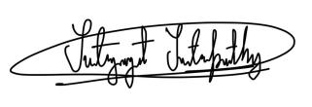
[Signature of Students]
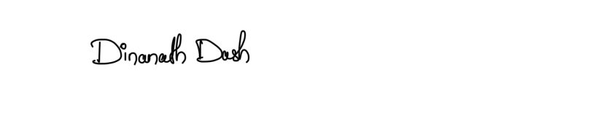
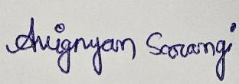
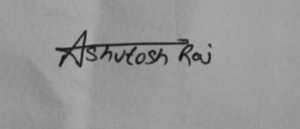
3.
4.
As a Supervisor, I will collect and make necessary changes in the prepared article (if needed) and shall submit to the Senior Design Project Coordinator by 20th June, 2026.

Dr. Bhanu Pratap Rajak
[Signature of Supervisor]

